

**AI-Driven Crop Disease Prediction and Management System**

**A PROJECT REPORT**

## 

***Submitted by***

HARSHITHA V- 20221ISE0077

TAANYA SUBBAIAH B- 20221ISE0082

M ASWIN- 20221ISE0065

### *Under the guidance of,*

**Dr. Murali Parameswaran**

**BACHELOR OF TECHNOLOGY**

**IN**

**INFORMATION SCIENCE AND ENGINEERING**

**PRESIDENCY UNIVERSITY**

**BENGALURU**

**DECEMBER 2025**



**PRESIDENCY SCHOOL OF COMPUTER SCIENCE AND ENGINEERING**

**BONAFIDE CERTIFICATE**

Certified that this report “**AI-Driven Crop Disease Prediction and Management System**” is a Bonafide work of “HARSHITHA V (20221ISE0077), TAANYA SUBBAIAH B (20221ISE0082), M ASWIN (20221ISE0065)”, who have successfully carried out the project work and submitted the report for partial fulfilment of the requirements for the award of the degree of BACHELOR OF TECHNOLOGY in INFORMATION SCIENCE AND ENGINEERING during 2025-26.

|  |  |  |  |
| --- | --- | --- | --- |
| **Dr. Murali Parameswaran**  Project Guide  PSCS  Presidency University | **Ms. Suma N G**  Program Project Coordinator  PSCS  Presidency University | **Dr. Sampath A K**  **Dr. Geetha A**  School Project Coordinators  PSCS  Presidency University | **Dr. Zafar Ali Khan**  Head of the Department PSCS  Presidency University |

|  |  |  |  |
| --- | --- | --- | --- |
| **Dr. Shakkeera L**  Associate Dean  PSCS  Presidency University |  |  | **Dr. Duraipandian N**  Dean  PSCS & PSIS  Presidency University |

**Examiners**

|  |  |  |  |
| --- | --- | --- | --- |
| Sl. no. | Name | Signature | Date |
| 1 |  |  |  |
| 2 |  |  |  |

**PRESIDENCY UNIVERSITY**

**PRESIDENCY SCHOOL OF COMPUTER SCIENCE AND ENGINEERING**

DECLARATION

We the students of final year B.Tech in INFORMATION SCIENCE AND ENGINEERING at Presidency University, Bengaluru, named HARSHITHA V, TAANYA SUBBAIAH B, M ASWIN, hereby declare that the project work titled **“AI-Driven Crop Disease Prediction and Management System”** has been independently carried out by us and submitted in partial fulfilment for the award of the degree of B.Tech in INFORMATION SCIENCE AND ENGINEERING during the academic year of 2025-26. Further, the matter embodied in the project has not been submitted previously by anybody for the award of any Degree or Diploma to any other institution.

HARSHITHA V USN: 20221ISE0077

TAANYA SUBBAIAH B USN: 20221ISE0082

M ASWIN USN: 20221ISE0065

PLACE: BENGALURU

# DATE:

# ACKNOWLEDGEMENT

For completing this project work, we have received the support and the guidance from many people whom I would like to mention with deep sense of gratitude and indebtedness. We extend our gratitude to our beloved **Chancellor, Vice Chancellor, Pro-Vice Chancellor, and Registrar** for their support and encouragement in completion of the project.

I would like to sincerely thank my internal guide **Dr. Murali Parameswaran, Professor**, Presidency School of Computer Science and Engineering, Presidency University, for her moral support, motivation, timely guidance and encouragement provided to us during the period of our project work.

I am also thankful to to **Dr. Zafar Ali Khan, Professor, Head of the Department, Presidency School of Computer Science and Engineering** Presidency University, for his mentorship and encouragement.

We express our cordial thanks to **Dr. Duraipandian N**, Dean PSCS & PSIS, **Dr. Shakkeera L**, Associate Dean, Presidency School of computer Science and Engineering and the Management of Presidency University for providing the required facilities and intellectually stimulating environment that aided in the completion of my project work.

We are grateful to **Dr Sampath A K, Dr Geetha A., PSCS** school Project Coordinators**, Ms Suma N G, Program Project Coordinator**, Presidency School of Computer Science and Engineering, for facilitating problem statements, coordinating reviews, monitoring progress, and providing their valuable support and guidance.

We are also grateful to the Teaching and Non-Teaching staff of Presidency School of Computer Science and Engineering, and also staff from other departments who have extended their valuable help and cooperation.

HARSHITHA V

TAANYA SUBBAIAH B

M ASWIN

# ABSTRACT

Agriculture is among the most significant industries that guarantees of world’s food supply and economic sustainability. Crop diseases are a major problem, with about 40 percent of the total crop yield lost annually. Conventional methods of detecting these diseases like manual inspection by skilled personnel is time consuming and expensive as well as inaccurate in detection when applied on vast agricultural areas.

The emergence of Artificial Intelligence (AI) and especially, Machine Leaming (ML) and Deep Leaming (DL) has provided a new course in the direction of contemporary agriculture. The technologies offer quicker, dependable, and economical ways of detecting and monitoring disease in its early stages. In this work, we examine Convolutional Neural Networks (CNNs) and Vision Transformers (ViTs), for identifying and classifying crop diseases based on leaf images using automated image analysis. We also address the general workflow of the system -- beginning with the collection of data through remote sensing and IoT-based sensors; continuing with the data preprocessing step, the training and the deployment of models on cloud and edge computing.

Agricultural datasets that are publicly available are explored to analyse various aspects of their problems, including data imbalance, bias, and limited real-world generalization. Evaluation of the key performance measures of AI models including accuracy, precision, recall, and Fl score are performed, giving us values of 99.0%, 98.7%, 98.9%, and 98.8% respectively. This work can be extended by developing hybrid models combining various AI methods, optimization of multi-modal data integration based on satellite, soil, and weather data, and the application of Federated Leaming to preserve the privacy of farmer data and increase scalability.

TABLE OF CONTENTS

|  |  |  |
| --- | --- | --- |
| **Sl. No.** | **Title** | **Page No.** |
|  | Declaration |  |
|  | Acknowledgement | i |
|  | Abstract | ii |
|  | List of Figures | v |
|  | List of Tables | vi |
|  | List of Abbreviations | vii |
| 1. | Introduction  1.1 Background  1.2 Statistics of the project  1.3 Prior existing technologies  1.4 Proposed approach  1.5 Objectives  1.6 SDGs  1.7 Overview of project report | 1 |
| 2. | Literature Review | 8 |
| 3. | Methodology | 14 |
| 4. | Project management  4.1 Project timeline  4.2 Project planning  4.3 Project budget | 19 |
| 5. | Hardware, Software, and Simulation  5.1 Hardware  5.2 Software development tools  5.3 Dataset  5.4 Models Used  5.5 Software code  5.6 Simulation | 23 |
| 6. | Evaluation and Results  6.1 Test points  6.2 Test plan  6.3 Test result  6.4 Insights | 31 |
| 7. | Social, Legal, Ethical, Sustainability, and Safety Aspects  7.1 Social aspects  7.2 Legal aspects  7.3 Ethical aspects  7.4 Sustainability aspects  7.5 Safety aspects | 41 |
| 8. | Conclusion | 44 |
| 9. | References | 46 |
| 10. | Appendix | 48 |

LIST OF FIGURES

|  |  |  |
| --- | --- | --- |
| **Figure no.** | **Caption** | **Page No.** |
| Figure 1.1 | Global Causes of Food Chain Emergencies, Incidence, and Crop Losses | 2 |
| Figure 1.2 | Proposed AI-based crop disease detection system workflow | 4 |
| Figure 1.3 | Sustainable development goals | 6 |
| Figure 1.4 | SDG Alignment of Crop Disease Detection Project | 6 |
| Figure 3.1 | : System Flowchart | 16 |
| Figure 3.2 | The Layered Architecture of the Proposed System | 17 |
| Figure 4.1 | Capstone Project Gantt Chart | 21 |
| Figure 5.1 | Architecture of Custom CNN (PlantDiseaseModel) | 26 |
| Figure 5.2 | Architecture of Early Stopping Mechanism | 27 |
| Figure 5.3 | Architecture of Grad-CAM | 28 |
| Figure 5.4 | Architecture of the Interactive Disease Diagnosis System | 29 |
| Figure 6.1 | Healthy vs Diseased Image Distribution by Plant Type | 32 |
| Figure 6.2 | Image Distribution by Plant Type (Donut Chart) | 33 |
| Figure 6.3 | Training and Validation Loss Curve | 34 |
| Figure 6.4 | Validation Accuracy Curve | 35 |
| Figure 6.5 | Model Accuracy by Plant Type | 36 |
| Figure 6.6 | Grad-CAM Visualization Samples | 38 |
| Figure 6.7 | Final Disease Diagnosis & Treatment Recommendation Interface | 39 |
| Figure A.1 | Function used to show plant disease images | 48 |
| Figure A.2 | Visual samples of plant leaf diseases used for model training. | 49 |
| Figure A.3 | Data augmentations applied during preprocessing | 49 |
| Figure A.4 | Data augmentation outputs used for enhancing the plant disease dataset. | 50 |
| Figure B.1 | Diagnosis & Recommendation Engine Script | 50 |
| Figure B.2 | AI-Based Plant Disease Diagnosis with Treatment Recommendations | 51 |

LIST OF TABLES

|  |  |  |
| --- | --- | --- |
| **Table No.** | **Caption** | **Page No.** |
| Table 1.1 | Regional crop losses and common diseases in India | 2 |
| Table 2.1 | Summary of Literature Reviews | 10 |
| Table 4.1 | Project Planning and Implementation Timeline | 19 |
| Table 4.2 | Project Resources and Estimated Cost | 22 |
| Table 6.1 | Test results of CNN Models | 40 |

LIST OF ABBREVIATIONS

| **Abbreviation** | **Full Form** |
| --- | --- |
| AI | Artificial Intelligence |
| APDDC | Automated Plant Disease Detection and Classification |
| Avg | Average |
| CNN | Convolutional Neural Network |
| CV | Computer Vision |
| DL | Deep Learning |
| F1 Score | Harmonic mean of Precision and Recall |
| FAO | Food and Agriculture Organization |
| Fig. | Figure |
| GPU | Graphics Processing Unit |
| Grad-CAM | Gradient-Weighted Class Activation Mapping |
| HOD | Head of the Department |
| ICAR | Indian Council of Agricultural Research |
| IDE | Integrated Development Environment |
| IoT | Internet of Things |
| KNN | K-Nearest Neighbors |
| ML | Machine Learning |
| NumPy | Numerical Python |
| OpenCV | Open-Source Computer Vision Library |
| PC | Personal Computer |
| PSCS | Presidency School of Computer Science and Engineering |
| ReLU | Rectified Linear Unit |
| ROI | Region of Interest |
| SDG | Sustainable Development Goals |
| SE Block | Squeeze-and-Excitation Block |
| SPEDCCNN | Segmentation-based Plant Disease Detection CNN |
| SVM | Support Vector Machine |
| TFLite | TensorFlow Lite |
| TL | Transfer Learning |
| VGG | Visual Geometry Group |
| ViT | Vision Transformer |

# Chapter 1

**INTRODUCTION**

**1.1 Background**

Farming plays an important role in supporting economy besides ensuring food security in the whole world. The associated pathogens which may include fungi, bacteria and viruses may cause crop diseases that will lead to reduced output and quality of the crop which will ultimately affect not only the income of the farmers but also the food availability. However, these methods are not very accurate and time-intensive, which is why they cannot be used in the extensive agriculture industry. With the advent of Artificial Intelligence (AI) and Machine Learning (ML), it is possible to create automatic systems that will be capable of analysing crop images and diagnosing the disease more quickly and accurately. The technologies help in reducing the amount of human labour and improve the rate and precision of the disease detection.

1. **The system uses deep learning, namely artificial intelligence** (AI) based system of crop diseases prediction and management.
2. **Convolutional Neural Networks (CNNs)** in order to successfully and accurately identify crop diseases through leaf images.

**1.2 Statistics and Need of the Project**

There are a number of worldwide components that cause significant changes in the food chain, such as climatic change, extensive food production complex, population expansion, and urbanization. Other significant agricultural statistics are also indicated in the infographic, which includes the following; Plant pests and diseases which cause almost 30 percent of losses in crop production around the world, forest insect pests that are infecting over 85 million hectares, and more than 200 diseases spread through food. It further demonstrates that globalization and excessive weather conditions can raise the rate of crop-related crisis. Collectively, these comments indicate how critical the development of sophisticated AI-powered crop disease prediction systems is that could assist farmers in decreasing losses and enhancing food security. Decreasing losses and enhancing food security.

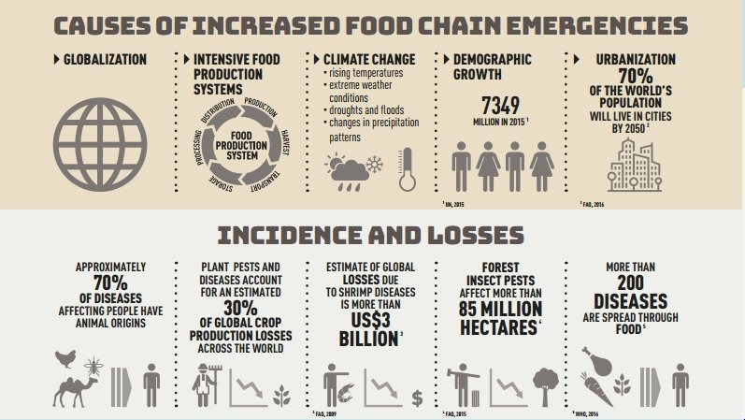

*Figure 1.1: Global Causes of Food Chain Emergencies, Incidence, and Crop Losses*

**Regional Crop Losses Due to Diseases (India)**

*Table 1.1: Regional crop losses and common diseases in India*

| **Crop** | **Region** | **Annual Loss (%)** | **Common Diseases** |
| --- | --- | --- | --- |
| Potato | Uttar Pradesh | 25–30% | Late blight, Common scab |
| Tomato | Maharashtra | 20–25% | Bacterial wilt, Leaf curl |
| Rice | West Bengal | 15–20% | Blast, Sheath blight |
| Banana | Tamil Nadu | 10–15% | Panama disease, Sigatoka |

**1.3 Prior Existing Technologies**

1. Crop disease detection has several technologies: Expert Systems: The expert-driven systems that are rule-based; can be scaled and modified.
2. Image Processing Techniques: extraction (color, texture, shape) and classical (SVM or KNN) classifier. Lighting and image quality are performance sensitive [Patel, 2020].
3. Deep Learning-based Systems: CNNs are quite precise in identifying diseases with the aid of images, yet they will only focus on a limited set of crops and diseases [Singh et al., 2021].

**1.4 Proposed Approach**

1. **Purpose:** Design an artificial intelligence-based crop disease detector appliance, capable of identifying multiple crop diseases and providing treatment suggestions.
2. **Motivation:** Timely detection reduces crop wastage, optimum crop yield and saves on resources of the farmer. With the use of mobile, it is available even in the rural areas.
3. **Proposed Approach:** Preprocess pictures of crops having various diseases and take pictures of them. Predict the diseases with deep learning (CNN). Create a mobile/ web interface to provide real time findings on detection to the farmers.
4. **Applications:** Technology in agriculture management, precision farming, technology in educating farmers, automated monitoring with the use of IoT.
5. **Limitations:** The image quality may be poor thus lowering performance. Cases that are few can reduce the detection accuracy since few cases are available. New diseases should be introduced into the system on a constant basis.

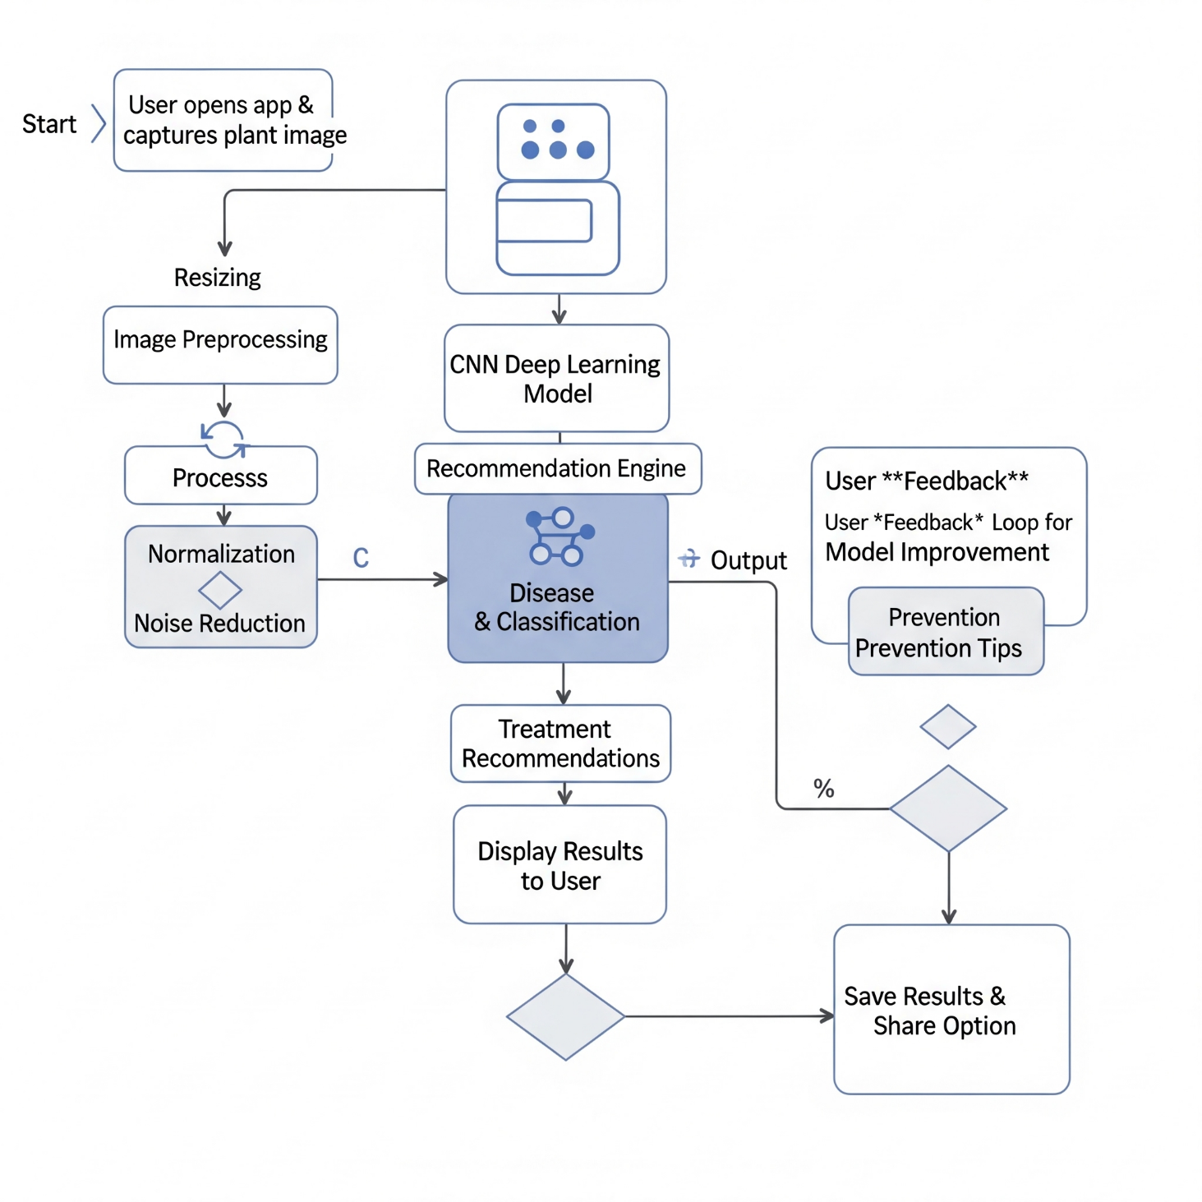*Figure 1.2: Proposed AI-based crop disease detection system workflow.*

The figure above shows the entire process flow of the AI-based crop disease detection system, starting with the point when the user takes a picture of a plant leaf with the help of the mobile app. The image is then initially subjected to preprocessing procedures like resizing, normalizing, and noise reduction so that the quality of images can be uniformly guaranteed before being introduced to CNN deep learning model. After processing, the model does the disease classification and transmits the result to the recommendation engine which produces suitable treatment recommendations and prevention tips depending on the identified disease. These findings are further presented to the user in an easy and friendly interface.

**1.5 Objectives**

This project aims at creating an image-based diagnostic system that can examine a leaf picture and give an answer, as to whether the plant is healthy or affected by a known disease to the respective crop. The model is trained with three major crops Tomato, Potato, and Pepper and it classifies images of leaves as healthy or diseased. The predicted class is provided by the system combined with important performance indicators ACC (Accuracy) the number of times that the model predicts correctly on average and PR (Precision) the degree to which the model accurately predicts a disease when it predicts it. Depending on the performance of the trained model, the system had high values of accuracy of crop types with 99.7, 98.8, and 95.0, respectively, which is a good indication of potential use in real-life agricultural diseases detection. The objective of the project is to come up with a powerful AI-based system that will be able to identify various diseases that affect crops with a high degree of reliability and efficiency. The system can be trained to use deep learning models to combine image processing techniques with the deep learning models to analyse leaf images and identify the health status of the crop. The other important goal is to create the convenient and user-friendly interface which will enable the farmers to access the disease detection results with ease and without any technical skills. Moreover, the system should be scalable and flexible so that it is able to accommodate region-specific crop varieties besides future new and emerging plant diseases.

**1.6 SDGs Alignment**

The project aligns with the following UN Sustainable Development Goals (SDGs):

1. **SDG 2: Zero Hunger**

Early and accurate detection of crop diseases improves agricultural productivity and reduces losses, ensuring better food availability. By helping farmers protect their crops, the system contributes directly to achieving food security.

1. **SDG 3: Good Health & Well-being**

Healthy crops lead to safer food chains, reducing the risk of contaminated or diseased produce reaching consumers. This enhances public health by supporting access to cleaner, healthier food.

1. **SDG 12: Responsible Consumption**

Timely diagnosis minimizes wastage caused by undetected diseases and encourages more efficient use of resources. This promotes sustainable agricultural practices and reduces environmental impact.

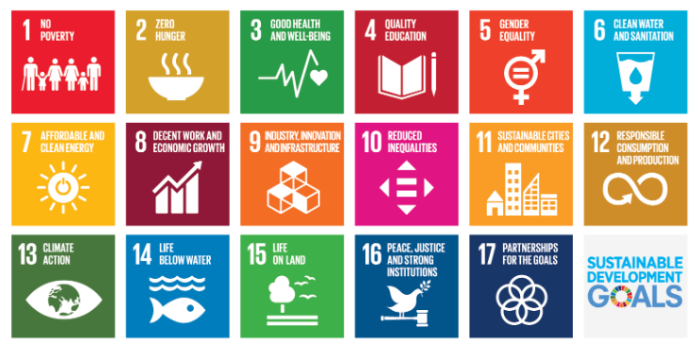

*Figure 1.3 Sustainable development goals*

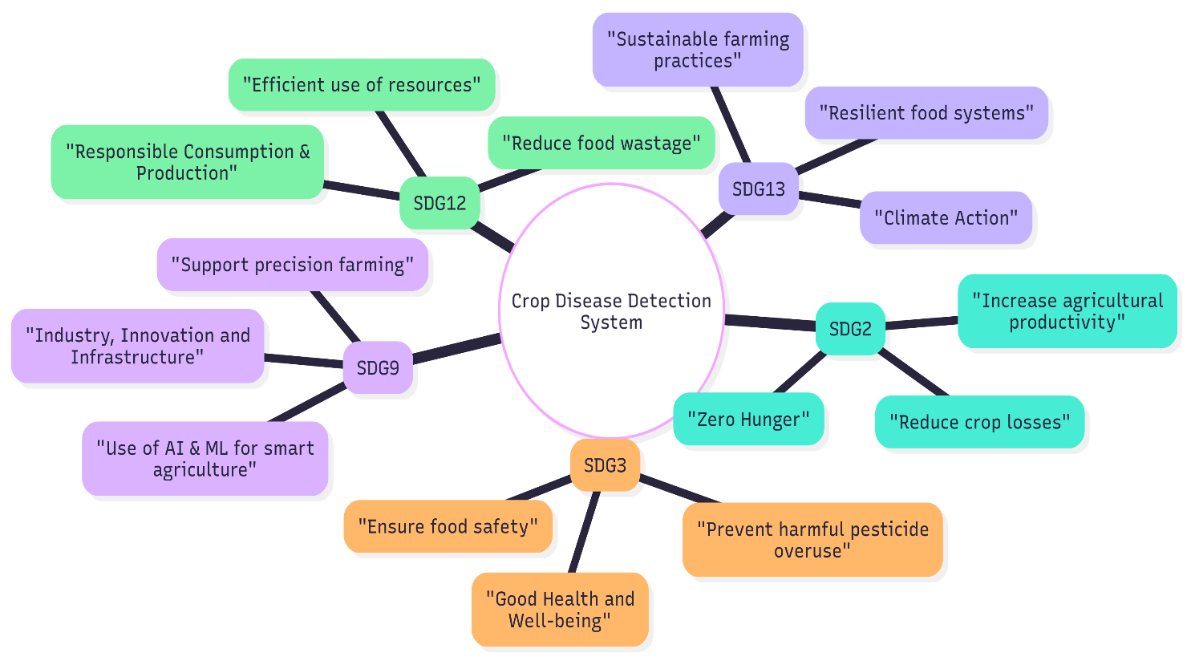

*Figure 1.4 SDG Alignment of Crop Disease Detection Project*

**1.7 Overview of Project Report**

You are allowed to give a preview of our project in full in this report. Chapter 1 starts with the statement of the project, objectives, and our general idea. Chapter 2 is about other studies that are already in existence and what we learned. Chapter 3 explains the process in which we will build the system. Chapter 4 is purely founded on the manner in which we will manage the project, the timeline, and the budget. In chapter 5, the project timeline is given. Chapter 6 discusses all the hardware and software tools that we are using. Chapter 7 takes the big picture of the project, like its impact on people and environment. Finally, Chapter 8 then leaves it all to the end of our work by recapping it and saying what to do next.

Chapter 2

**LITERATURE REVIEW**

**Li et al. [1]** provided an elaborate and comprehensive survey of the application of the deep learning techniques in crop disease detection, based on the emerging paradigm of automated feature learning with the use of CNNs and the removal of the traditional handcrafted feature extraction methods. Their discussion pointed out that deep learning has a huge drop in human error and inter-observer variability that are widespread during the manual inspection. They also talked about the ability of CNNs to learn complex visual images like texture, color abnormalities and morphology of lesions, compared to traditional machine learning models. Nevertheless, they emphasized that the vast majority of successful deep learning models are trained on controlled datasets regarding lighting and background and, thus, it is challenging to expect them to work in the field on real farms where conditions are extremely non-uniform. The paper also suggested an augmentation of data at a large scale, domain adaptation, and expansion of data at the field level as future research topics.

**Yu and Son [2]** introduced a specialized CNN model, which calls the Region of Interest (ROI) and isolates it, then classifies this ROI to allow the model to locate only infected areas of the leaf. The ROI-based method eliminates noise of healthy leaf area, as well as background clutter causing greater accuracy in classification. They did show that isolating diseased areas enhances the sensitivity of the model upon faint symptoms of crop disease which would otherwise escape capture. However, their approach relies extensively on computationally intensive algorithms of ROI extraction, which raises the costs of processing time and makes the extraction mode unfeasible in real time and mobile applications. They proposed to optimise in future by means of light weight segmentation models or embedded hardware acceleration.

**Ahmad et al. [3]** examined the obstacle of moving the models of disease detection in the laboratory context to the real field through the help of attention models i.e. channel attention and spatial attention. These processes assist the model to identify the most informative areas in a picture including edges of the lesions, coloration, and irregularities in the veins. They tested their experiments on datasets that were more varied, community-sourced and they exhibited a better robustness. Another point raised by them was that models based on attention minimize the reliance on massive convolutional layers through more specific and efficient feature extraction. Nonetheless, the authors admitted that the limited or biased datasets cannot be completely covered using attention mechanisms and that field-level image collection and other regularization activities are necessary.

**Vanegas et al. [4]** used a two-step pipeline of deep transfer learning to diagnose maize diseases and they had to reuse a knowledge acquired by large-scale image datasets and applied it in agriculture. They pitted huge models such as VGG and ResNet against lightweight ones such as MobileNet and ShuffleNet. Their results indicated that smaller models were as accurate as deeper CNNs obtained faster and could be trained with far less computation resources. This carries a vehement implication on the implementation of disease detection systems on low-end devices and smart phones that are in use by farmers. Another point that they made is that lightweight models are more resilient to scarce training data and therefore the model can be employed in parts of the world where images are not annotated.

**Mohanty et al. [5]** made a benchmark study on the PlantVillage, which is one of the largest known labelled plant disease repositories, containing 14 crops and 26 disease categories. Their experiment proved that deep CNNs are always more effective than using conventional SVM or Random Forest classifier based on manually designed features. They further demonstrated that CNNs are high-classification systems that can be trained on top of massively different combinations of crops and diseases. Nevertheless, they recognised a serious drawback: the images in PlantVillage are taken in controlled settings with plain backgrounds, which will not be the like in the real farm setting. Consequently, the model that is only trained with these data sets might be unsafe under natural light, soil, leaf cover, and noise.

**Chen et al. [6]** developed a better CNN model designed with tomato leaf disease recognition in particular with fine-tuning that has a specific body of visual activity of tomato pathogens. Their changes were made on the basis of even more convolutional layers and filter size optimization and more efficient preprocessing to extract the color and texture better. The performance of their model was much higher compared to baseline CNNs with regard to tomato diseases. They however pointed out that this crop specific model had no generalizability, that is, it could not be extended to other crops, such as potato or pepper at all without serious retraining. It is a constraint that produces a trade-off between high accuracy when detecting a single crop, and being able to detect a variety of species.

**Raikar et al. [7]** will enhance precision agriculture by identifying and classifying diseases, which are detected in agriculture. They incorporated several deep learning approaches within their system, which consisted of more sophisticated feature extraction layers, more extensive training image sets, and cross-validation to enhance the reliability. Their findings revealed that their performances were better than classical machine learning methods hence their model is applicable in real-time monitoring. They further reasoned that these AI-enhanced systems have the potential to highly cut labour expenses, reach greater crop output, and help farmers in making decisions automatically. However, they have made it clear that there are still constraints of infrastructure in the rural places like bad internet access, and the ability of devices that the rural places can accommodate, are obstacles to the mass deployment.

**Zhang et al. [8]** was aimed at the identification of three major diseases of lavage maize used with a meticulously tweaked deep CNN architecture. They demonstrated great accuracy on their model when they were trained with clean datasets that were well curated. They have shown that crop special models perform well where disease patterns are visually differentiated and training images are uniform. The authors however discovered that their model could not transfer to other species not related to crops meaning that the model had low transferability. They observed that diversity in datasets is paramount in obtaining high applicability and future research in this area should address multi-crop dataset and domain adaptation methods.

*Table 2.1: Summary of Literature Reviews*

| **Ref No.** | **Author(s) & Year** | **Method/Model** | **Key Contribution/Remarks** | **Pros** | **Cons** |
| --- | --- | --- | --- | --- | --- |
| [1] | Li et al., 2021 | Review of deep learning in agriculture | Identified gaps in the real-world deployment of DL models | Comprehensive overview of the field | Highlights the challenge of translating lab results to the real world |
| [2] | Yu & Son, 2020 | ROI-aware CNN | Better precision, but computationally heavy | Enhances accuracy by focusing only on diseased areas of the image | The method might be too computationally demanding for mobile devices |
| [3] | Vanegas, M. A., 2022 | Deep transfer learning with lightweight CNNs | Lightweight models achieve similar accuracy with better training efficiency | Efficient for mobile apps, performs well with limited data | May not reach the absolute highest accuracy of larger models |
| [4] | Mohanty et al., 2016 | CNN on PlantVillage dataset | High accuracy, but limited to lab conditions | Foundational paper that proved deep learning can be highly accurate | Relied on a controlled dataset, not representative of real-world scenarios |
| [5] | Chen et al., 2021 | Improved CNN for tomato leaf diseases | Enhanced accuracy for a single crop | Modifying architectures can significantly boost accuracy for one crop | Lacks generalizability needed for multi-crop applications |
| [6] | Raikar et al., 2022 | DL Model for precision agriculture | Enhanced automated detection performance | Introduced a new model to improve outcomes in precision agriculture | As a custom model, it may be less benchmarked than standard architectures |
| [7] | Zhang et al., 2018 | CNN for maize leaf diseases | High accuracy on the maize dataset; limited scalability | Achieved exceptionally high performance on a crop-specific model | Findings are not easily generalized to other crops |
| [8] | Too et al., 2019 | Fine-tuning pre-trained CNNs (VGG, ResNet) | Improved accuracy but requires large computing resources | Improved accuracy | Requires large computing resources |
| [9] | Ferentinos, 2018 | Deep CNN models for diagnosis | High accuracy (>99%), but less effective in real field conditions | Very high accuracy in lab settings | Less effective in real-world conditions |
| [10] | Jiang et al., 2019 | Improved CNN for apple leaves | Robust real-time detection, but crop-specific | Works in real-time | Only works for a specific crop (apples) |
| [11] | Sladojevic et al., 2016 | Applied CNNs for leaf classification | Good accuracy on a small, lab-based dataset | Achieved good accuracy | Tested on a small dataset from a lab |
| [12] | Amara et al., 2017 | CNN for banana leaf diseases | Strong accuracy for a specific crop; requires larger datasets | Strong accuracy for bananas | Requires large datasets to work well |
| [13] | H. R. J. R, et al., 2021 | AI & IoT Integration | Combines real-time data with predictive AI for effective treatment | Integrates IoT data for better predictions | Requires significant infrastructure (sensors, connectivity) to implement |
| [14] | Singh et al., 2023 | Systematic review of image-based detection | Highlights challenges like a lack of diverse datasets & real-world performance | Provides a good overview of challenges in the field | Does not propose a new technical solution itself |
| [15] | Wang et al., 2021 | CNN with Attention Mechanisms | Improved accuracy by focusing on key disease features | Improved accuracy with attention | Can increase model complexity and training time |
| [16] | A. A. S., et al., 2022 | Lightweight CNN for mobile devices | Optimized for real-time, on-device detection | Good for real-time use on phones | May sacrifice some accuracy for speed and size |
| [17] | Karthik et al., 2023 | IoT-based smart farming with ML | Uses IoT sensor data fusion to improve disease prediction | Improves predictions with sensor data | High dependency on sensor data quality and network reliability |
| [18] | Al-Gaashani et al., 2025 | Modified Depthwise CNN with SE blocks | High accuracy (98%) and F1 score; computationally efficient | High accuracy and efficient | Modifications add some architectural complexity |
| [19] | Picon et al., 2022 | Lightweight CNN with TensorFlow Lite | Real-time on-device diagnosis with >90% accuracy | High accuracy for real-time diagnosis on a device | TFLite models can have limitations compared to full models |
| [20] | Yuan et al., 2021 | SPEDCCNN for leaf segmentation | Helps understand the extent of precise treatment | Useful for planning precise treatments | Segmentation is more complex and resource-intensive than classification |
| [21] | Gholamreza et al., 2022 | Modified Lightweight CNN with Attention | Balanced performance and efficiency for embedded applications | Good balance of performance and efficiency | May not be as lightweight as other, simpler mobile models |
| [22] | Bera et al., 2024 | Attention-based deep network | State-of-the-art accuracy on multiple datasets using descriptive info | High accuracy on multiple datasets | May require extra descriptive data inputs beyond just the image |
| [23] | Kumar et al., 2025 | Blockchain & ML for agriculture | Integrates deep learning with blockchain for traceability & transparency | Adds security and transparency with blockchain | Blockchain integration adds significant complexity and overhead |
| [24] | Ramcharan et al., 2017 | TensorFlow Lite model on mobile devices | Demonstrated feasibility of on-device inference for real-world scenarios | Proved on-device detection is feasible | Early model, may be less optimized than recent ones |
| [25] | Khan et al., 2025 | Ultra-lightweight DL model | High performance (99.8%) with fewer parameters for practical applications | Very high performance with a small size | Extreme optimization may lead to trade-offs in robustness |

Chapter 3

**METHODOLOGY**

The traditional modes of identifying plant diseases rely on human observation that requires skills, time and funds. Early versions of ML using hand-written features and classifiers were both not scalable and they did not perform well in practice. Mobile applications are limited to certain crops, and they will not operate with the transformation of light, background, and shape of leaves.

**3.1** **DATASET**

In the given project, we took advantage of a selected set of leaf images known as the PlantVillage Dataset, which is a structured set of crop pictures with a specific aim of detecting plant diseases. The data is of nice quality images of three popular crops Tomato, Potato and Pepper further classified as healthy and diseased. It has a good visual representation of the characteristics of leaf textures, patterns of discoloration and pathogen-specific symptoms, which makes it useful in training CNN-based disease classification models.

**3.1.1 Crop 1: Tomato**

1. Tomato Bacterial Spot
2. Tomato Early Blight
3. Tomato Late Blight
4. Tomato Leaf Mold
5. Tomato Septoria Leaf Spot
6. Tomato Spider Mites (Two-Spotted)
7. Tomato Target Spot
8. Tomato Yellow Leaf Curl Virus
9. Tomato Mosaic Virus
10. Tomato Healthy

**3.1.2 Crop 2: Potato**

1. Potato Early Blight
2. Potato Late Blight
3. Potato Healthy

**3.1.3 Crop 3: Pepper (Bell Pepper)**

1. Pepper Bell Bacterial Spot
2. Pepper Bell Healthy

**Limitations:**

1. The method of hand inspection is both costly and time consuming and subject to error.
2. The artisan ML solutions are not scalable and robust.
3. Only a number of crops are available to use.
4. The precision decline is observed in a number of actual environments.

The proposed system starts with the picture taken by a cell phone or a camera. Images are pre-processed using OpenCV and NumPy. The classification between healthy and diseased is done by a TensorFlow CNN.

The system architecture can be described as follows:

1. Input Layer - captures crop leaf images.
2. Processing Layer- Preprocessing and normalization.
3. Model Layer - CNN classification according to the disease.
4. Decision Layer - Generates treatment and type of disease recommendation.

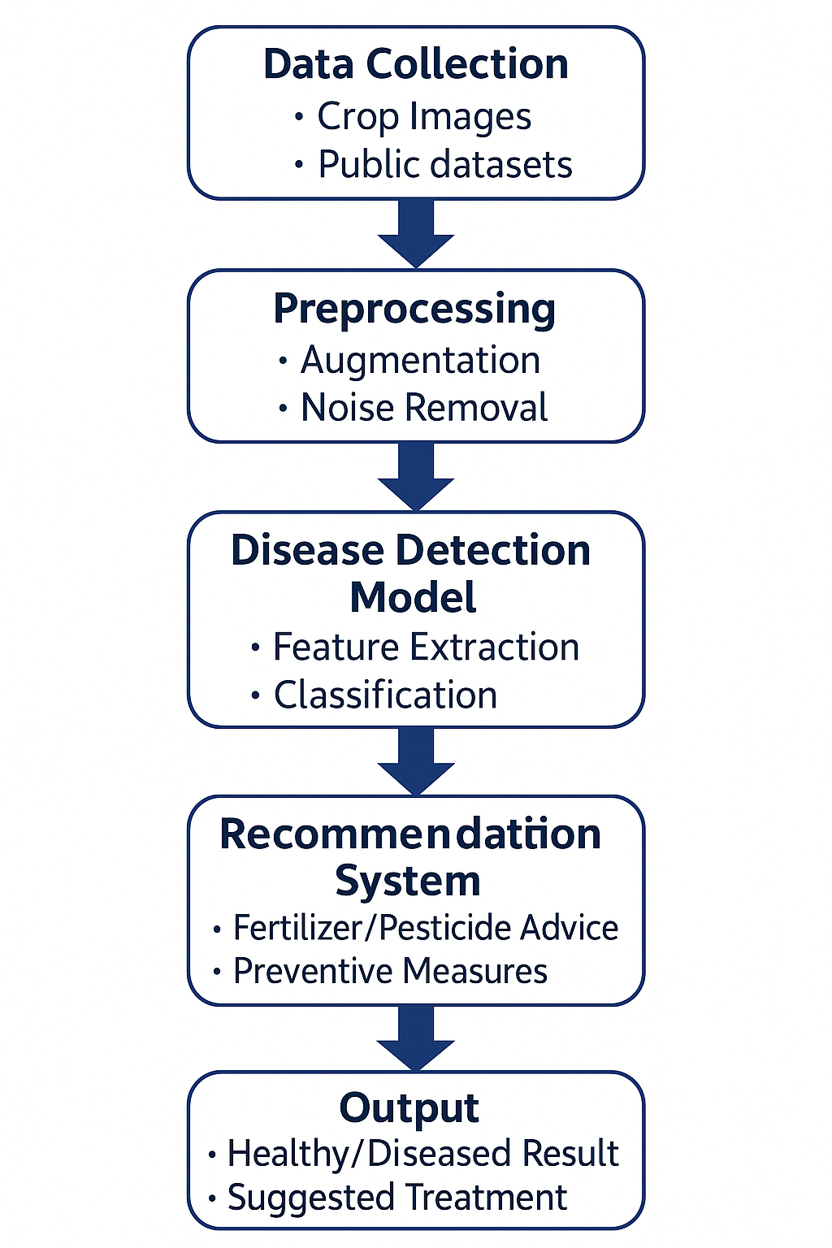

*Figure 3.1: System Flowchart*

The figure above shows the general process of the crop disease detection system based on AI, which begins with the collection of data and concludes with practical suggestions made to farmers. The process starts with Data Collection, during which crop images are collected in form of public datasets and real-fields creating a varied image repository. These images are then subjected to Preprocessing and augmentation and noise removal that improves quality, and removes the environmental and lighting error of the model when applied in different conditions.

Following the preprocessing, the images are entered to the Disease Detection Model where a Convolutional Neural Network (CNN) is used to extract the features and categorize the leaf as either healthy or diseased following the learned patterns. This type of classification is then forwarded to the Recommendation System which offers advice on the application of fertilizer or pesticides as well as preventative measures based on the disease identified. Lastly, the system produces the Output, which is the health status of the plant and the recommendations of the appropriate treatments to be used by farmers to make timely and knowledgeable decisions.

**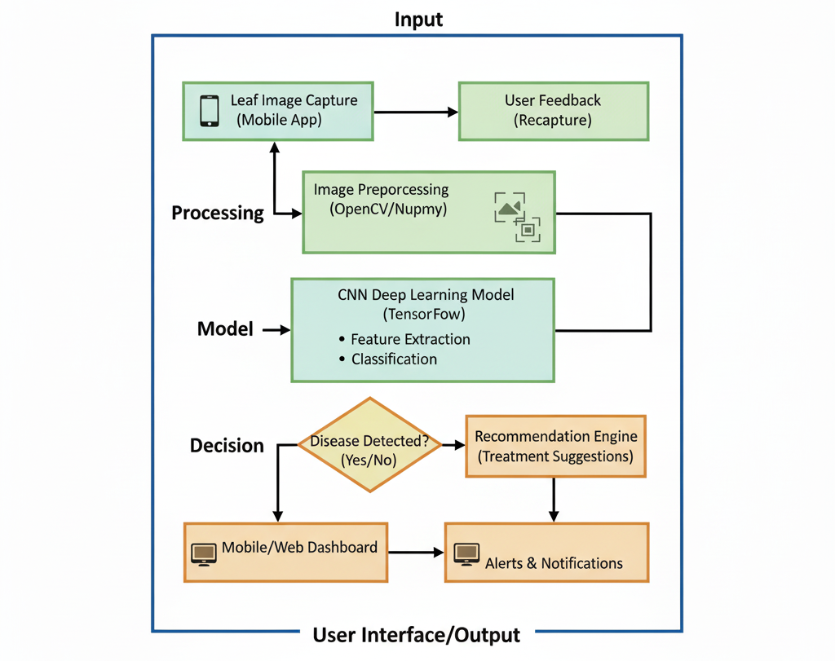***Figure 3.2: The Layered Architecture of the Proposed System*

The figure above shows the entire system architecture of the AI-based crop disease detection system, starting with the interaction with the user, up to the treatment recommendations that can be taken. The algorithm begins at the Input stage, where the user takes a leaf picture on a mobile application and can also give feedback on the picture by recapturing the picture and thus increasing the accuracy rate of the feedback.

The obtained image is then sent to Processing module where it is pre-processed with the help of applying OpenCV and NumPy to improve the image quality, filter noise, and standardize the data, which is then analysed. The pre-processed image is then sent to the Model stage, wherein the feature extraction and classification is done by a CNN-based deep learning model created with the help of the TensorFlow service, which determines whether the leaf is healthy or diseased. At the time that the model produces something, the system shifts to a Decision phase where it determines whether a disease has been detected. In case the image has been detected to have a disease, the output is passed through the Recommendation Engine, which finds a solution to the treatment including pesticide or fertilizer recommendations, and prevention. The module of User Interface/Output provides both healthy and disease outputs and can contain both a mobile or web dashboard to view predictions and alerts and notifications to enable farmers to act in time. This pipeline guarantees continuous pipeline of capturing images to diagnosis and eventually professional advice and therefore the system is applicable in monitoring crops in the field.

Chapter 4

**PROJECT MANAGEMENT**

Project management plays an important role in making sure a project is completed successfully. In this project, having a clear and visual timeline helps in tracking the progress, organizing tasks, and ensuring that all deadlines are met on time.

**4.1 Project Timeline**

Project timeline will be constructed through a Gantt chart to give a pictorial view of all major activities, milestones and their sequence of occurrence. The tool assists the team to monitor the progress of a project and recognize possible bottlenecks. The evaluation indicates the commencement and termination dates of the project as well as the time taken in each phase.

*Table 4.1: Project Planning and Implementation Timeline*

| **Task** | **Start Date** | **End Date** | **Duration (Weeks)** |
| --- | --- | --- | --- |
| Basic Prototype - Development Model 1 | 17-Aug-2025 | 31-Aug-2025 | 2 |
| Comparative Evaluation of All Models | 15-Sep-2025 | 15-Oct-2025 | 4 |
| Final Documentation | 10-Nov-2025 | 21-Nov-2025 | 1.5 |
| Documentation (1st to last week) | 17-Aug-2025 | 21-Nov-2025 | 14 |

**4.2 Project Planning**

The phase of project planning entailed the breakdown of the entire project into manageable tasks and logically scheduled the tasks. Figure 4.1 is the Gantt chart indicating the timetable of the planning as well as the implementation phase, with the key tasks and the corresponding deadlines. An example is the documentation process, which covers the whole life time of the project, the first week to the final week in order to make sure that progress is continuous.

* + 1. **Basic Prototype – Development Model 1 (17 August to 31 August)**

This stage aims at developing the first prototype of the disease detection model. The group works out the simple CNN structure, preprocesses sample pictures, and checks the initial predictions to ensure that the pipeline is working as intended. It forms the basis needed in the further development of models during later stages.

* + 1. **Comparative Evaluation of All Models (15 September to 15 October)**

In this step, several deep learning models and architectures are trained, tested and compared. Accuracy, loss, precision, recall and inference speed are some of the metrics of performance which are evaluated by the team. This is aimed at determining the model that performs optimally and it will be incorporated into the overall system.

* + 1. **Final Documentation (10 November to 21 November)**

This stage entails the preparation of the entire project documentation guide (methodology, dataset information, model architecture, results, discussions and conclusion). The team also makes sure that all the figures, tables and citations are well formatted to be submitted.

* + 1. **Documentation (17 August to 21 November)**

The process of documentation is done on a continuous basis in the project. The records of every week will be made, containing the preparation of datasets, the improvement of models, experimentation, and decisions on the design of the system. This will make sure that the final report portrays the entire process of development that is carried out throughout the entire process.

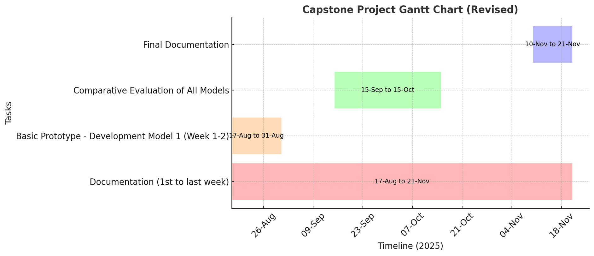

*Figure 4.1: Capstone Project Gantt Chart*

**4.3 Project Budget**

This project budget is extremely low as this system is supposed to be a low-cost system. It will use an available laptop or personal computer with a graphics card to process and a smartphone or a camera to take photos. All the software that is required which includes Python, TensorFlow and OpenCV is open source and free to use. This has led to the estimated cost of the project being almost zero.

*Table 4.2: Project Resources and Estimated Cost*

| **S.No** | **Item Description** | **Quantity** | **Estimated Cost (₹)** |
| --- | --- | --- | --- |
| **1** | **Hardware** |  |  |
|  | Dedicated laptop with GPU (suitable for training CNNs — e.g. laptop with NVIDIA GPU) | 1 | ₹ 1,80,000 |
|  | External Hard Disk / SSD (1 TB, e.g. SanDisk 1TB external SSD for storing large image data) | 1 | ₹ 13,000 |
|  | Input Device (Smartphone or Camera for leaf image capture) | 1 | ₹ 15,000 *(estimated typical budget smartphone cost)* |
| **2** | **Software & Tools** |  |  |
|  | Open-source libraries (Python, TensorFlow, OpenCV, NumPy — free) | **–** | ₹ 0 |
| **Consumables** | Subscription (e.g. Google Colab Pro for 2 months) | **–** | ₹ 3,000 *(approximate two-month subscription fee in India)* |
| **Contingency** | Documentation charges + Publication charges | **–** | ₹ 10,000 |

Chapter 5

**Hardware, Software, and Simulation**

**5.1 Hardware**

In this project, all the hardware requirements were installed to facilitate the training, testing, and implementation of the crop disease detection system. The deep learning models were built and trained in a dedicated laptop with an NVIDIA-powered GPU guaranteeing more rapidity in computations, effective parallel processing, and efficient manipulation of large data sets. A SanDisk 1TB external SSD was bought to organize the large range of leaf images and intermediate model files and serve as the main storage medium of the dataset management and backup. Besides that, a high-resolution camera phone was used as an input device to take samples of leaf pictures during testing and demonstrating. The project team personally bought and assembled all the hardware parts. Given that these resources, i.e. the laptop, the storage device and the input device, have been owned or bought by the team, the overall hardware configuration of the project was self-financed, and no external funding was needed.

1. **Functional Unit:** The processing unit is the Laptop or PC with a GPU, which is the hardware component.
2. **Integration:** These units are be able to interact with one another since the smartphone has the capability to take pictures and transmits them to the computer where the CNN model can perform its analysis. Once the processing is complete the results are displayed again to a user in the interface.
3. **Configuration:** The computer will be configured with the required GPU drivers and software to make sure that the computer will operate without facing any issues with the deep learning frameworks.

**5.2 Software development tools**

1. **Integrated Development Environment (IDE):** The Python programs are written and debugged with the help of a code editor like Visual Studio Code or PyCharm.
2. **Version Control System (VCS):** GitHub is a system which helps to deal with the versions of codes, monitor the changes and simplify the collaboration process of the members of the team.
3. **Cloud Platforms:** There is no direct requirement, but platforms, such as Google Colab, can be used to train the model with a remote GPU in case of a local GPU unavailable.
4. **Frameworks and Libraries:** The primary software infrastructure is designed around TensorFlow in which the CNN model is implemented, OpenCV in which images are processed and NumPy in which numerical calculations are performed.

**5.3 Dataset**

PlantVillage Dataset:

PlantVillage dataset is among the most frequently used benchmark dataset in plant disease detection studies. It consists of approximately 54, 306 leaf pictures categorized into 38 groups, which are a reflection of 14 crop species and its various diseases like tomato, potato, maize, apple, grape and pepper. The images were all under controlled conditions and the background and light were kept constant, and hence the dataset can be easily used to train the deep learning models such as CNNs. Even though this data has been used to obtain very high accuracy in experiments, the primary disadvantage of this data is that it has a limited range in the real world and thus it may be more difficult to apply in the field directly.

**5.4 Models Used**

**1. Custom CNN (PlantDiseaseModel)**

This is the primary model that will be applied in your project. It is a Convolutional Neural Network (CNN), which was not taken out of the shelf.

1. It consists of five convolutional blocks, each of which is learning more details of the leaf pictures.
2. Simple details such as texture or color are trapped by the initial couple of layers.
3. The intermediate layers are concerned with the forms or designs on the leaves.
4. The final layers are trained to recognize complicated signs of sickness or infection areas.
5. Then all this is subjected to some few fully connected layers which ultimately determine the type of disease it is.
6. It is being trained on the PlantVillage dataset that consists of various crops and ailments.

**2. Early Stopping Mechanism**

This is not really a model, it is a training guard. In training deep networks, they have a tendency to continue learning even after they have given their best thus overfitting. Early termination merely observes the validation loss. When a model ceases to make progress in a few rounds, it automatically halts and says, "Okay, I've done enough, I was just fooling around, and automatically goes out of business. It stores the most successful model to ensure that your performance is not deteriorated in the future. Consider it as an intelligent coach who understands when it is time to put the training behind him.

**3. Grad-CAM (Gradient-weighted Class Activation Mapping)**

Grad-CAM is a graphical explanation method.

Once a disease is predicted by the CNN, Grad-CAM will reveal where the model was actually appearing in the picture. It achieves this by tracing gradients of the previous convolutional layer in order to emphasize significant features - such as red heatmaps on infected areas. This allows you and users to have more faith in the model due to the fact that the concentration area is visible. It can also be applied to debugging, as when Grad-CAM shows the incorrect locations, you can realize that the model should be improved.

**4. Interactive Disease Diagnosis System**

This section ties all these points to each other and makes the system easy to use. It puts in the trained CNN model, and predicts the disease based on a provided picture, and it will show: The disease name, Percentage of confidence of the prediction. Severity level Therapy, suggestions of that disease.

**MODELS ARCHITECTURE:**

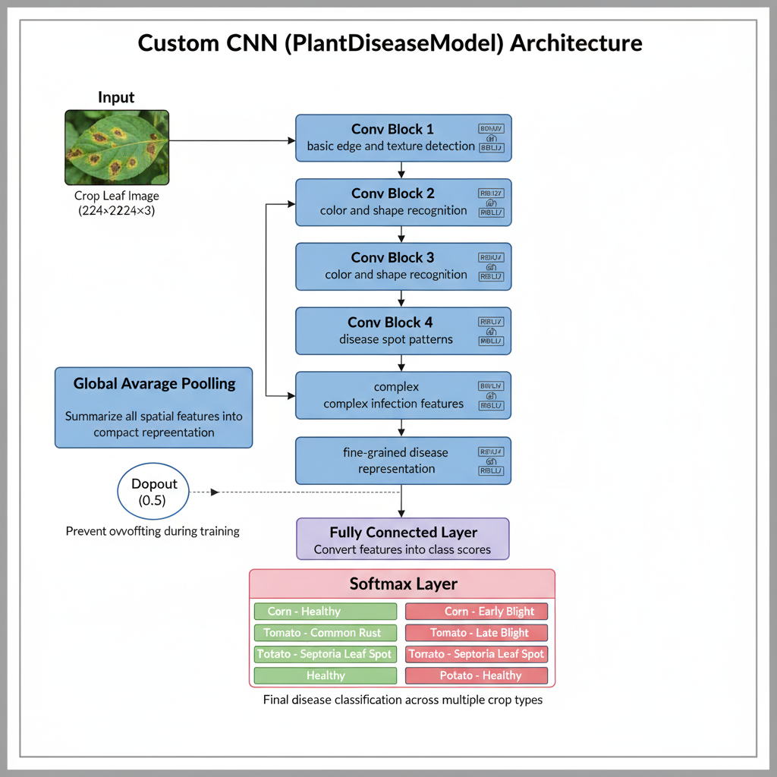

*Fig 5.1 Architecture of Custom CNN (PlantDiseaseModel)*

This is the figure of the custom CNN of crop disease classification. The convolutional blocks that the leaf image is exposed to sequentially acquire knowledge of edges, colors, shapes, and disease spots. The learned features are compressed by Global Average Pooling and overfitting is avoided with a dropout layer.

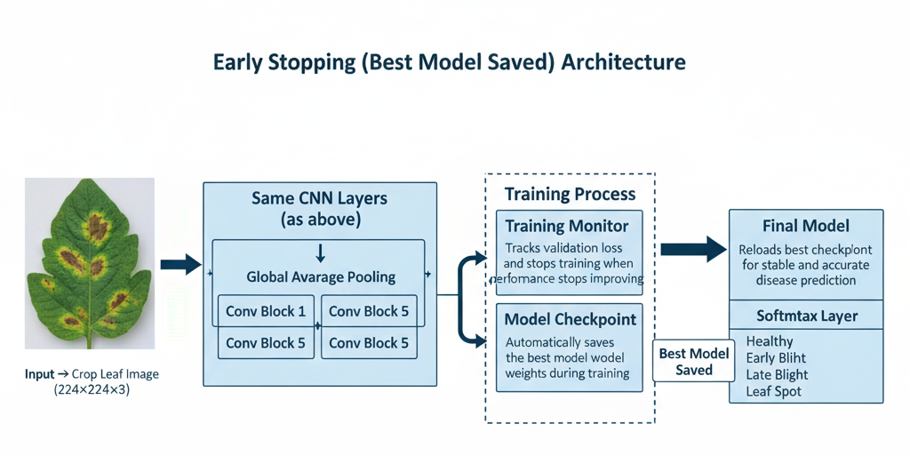

*Fig 5.2 Architecture of Early Stopping Mechanism*

This number depicts the training process that helps to avoid overfitting. The CNN layers are used to process the image and the training monitor follows the validation loss. At the point of improvement ceasing, training is terminated and the best-performing weights are automatically saved at a checkpoint. The last model is reloaded with these saved weights in order to make stable and correct predictions.

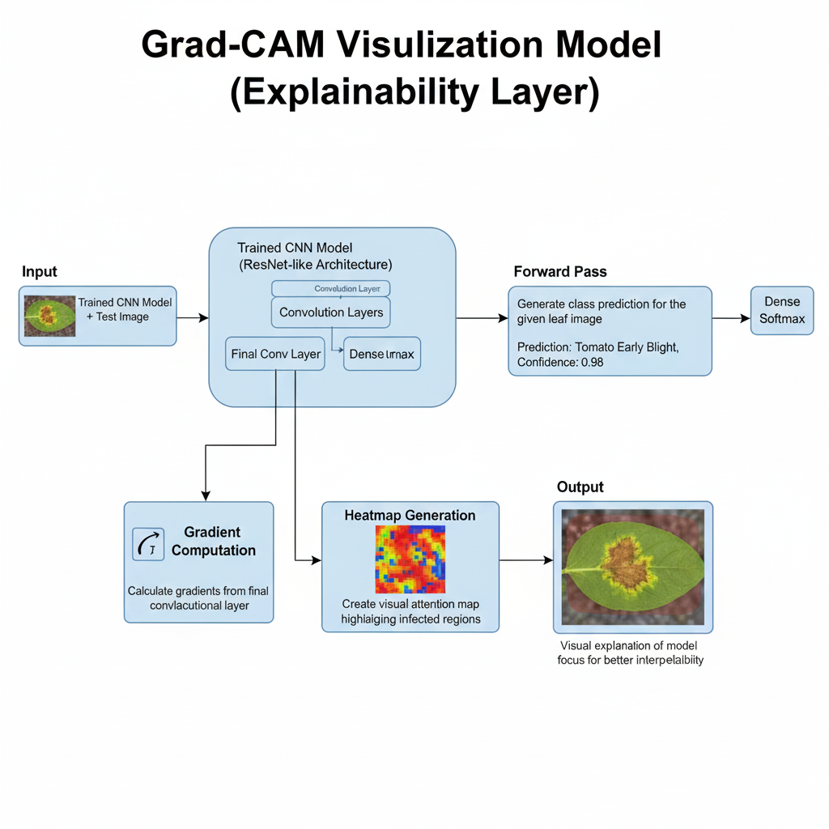

*Fig 5.3 Architecture of Grad-CAM (Gradient-weighted Class Activation Mapping)*

This characterization describes the fact that Grad-CAM is visually interpretable. When a disease is predicted by the CNN, the last convolutional layer will provide gradients that can be converted into a heatmap by showing the areas of the body which had been infected. The heatmap is superimposed on the leaf image that indicates the areas that the model focused on that can assist users in understanding the prediction.

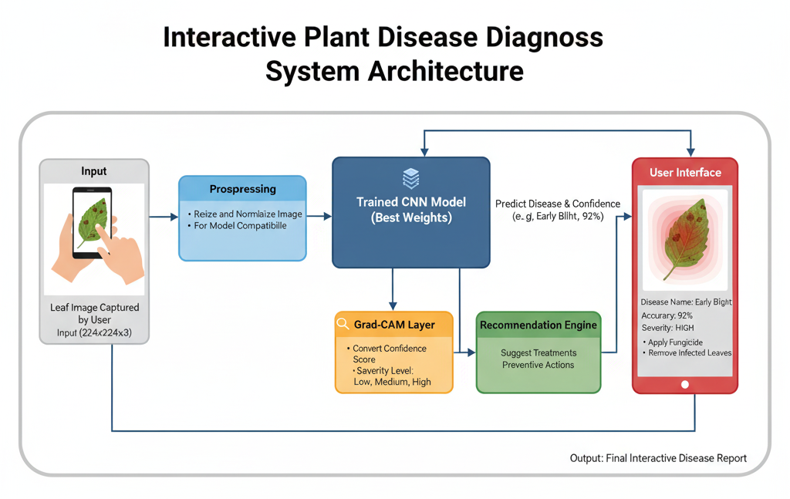

*Fig 5.4 Architecture of the Interactive Disease Diagnosis System*

This figure gives the entire diagnosis workflow. An image of a captured leaf is pre-processed and sent to the trained CNN model to be predicted and scored by confidence. Grad-CAM creates a visual heatmap and the recommendation engine proposes treatments. All findings such as name of disease, accuracy and guidance- are presented to the user in the mobile interface.

**5.5 ALGORITHM**

The algorithm starts by outlining a tailor-made Convolutional Neural Network (CNN) architecture that aims at classifying multiclass crop diseases. This model has a hierarchical feature extraction with four convolutional blocks and then a fully connected classifier to predict one of fifteen disease or healthy classes. The convolutional layers have ReLU activation and Max-Pooling that gradually decrease the spatial dimension to generate significant features in the visual image of the leaf, as depicted by the feature of the leaf. Training is carried out with Adam optimizer and Cross-Entropy Loss as the objective function and learning rate of 0.001. In each epoch, the algorithm loads mini-batches of training set images and labels, applies them through the network, calculates loss, backpropagates gradients and updates the model weights. Accuracy in training is determined by the comparison of the predicted labels and the real labels in each batch. Once all epochs have been completed, the model is then switched to evaluation mode and the final learned parameters are stored in the file. This trained model is then deployed to predict crop diseases in real time with the use of leaf images.

**5.6 Simulation**

This is with regard to the manner in which you would test your system without necessarily having a physical farm.

**Data-driven Simulation:** The most appropriate simulation that will be used in the project is to train and test the model on a large dataset of already collected images. This enables you to recreate real conditions of the world and test the performance of the model without necessarily having to deploy it to a physical place.

**Model Validation:** Cross-validation and validation of the model on unseen data: Simulation is a common technique to carry out cross-validation and validate how well the model generalizes to unseen data, a component of most machine learning projects.

Chapter 6

**Evaluation and Results**

The goal is to check that the system functions correctly, meets its objectives, and provides accurate results to farmers.

**6.1 Test Points**

In order to test the performance of the crop disease classification model, some of the important test points were tested based on the PlantVillage dataset. The data was separated into training, validation and testing, with the test set being made of unseen leaf images so that the correct measure of generalization of the model could be measured. Preprocessing like resizing, normalization and augmentation were put in place to enable the experiment setup to have even testing conditions. In the course of testing, different performance images were obtained such as **training-validation accuracy graph and trainings-validation loss curves and confusion matrices.** The graphs were used to monitor the learning behaviour of the model and identify such problems as overfitting or underfitting. The confusion matrix also gave an easy understanding of both correct and incorrect predictions of all the classes in the PlantVillage dataset.

To be evaluated, the following results of classification were noted:

1. **True Positive (TP):** Diseased leaf correctly predicted as diseased.
2. **True Negative (TN):** Healthy leaf correctly predicted as healthy.
3. **False Positive (FP):** Healthy leaf incorrectly predicted as diseased.
4. **False Negative (FN):** Diseased leaf incorrectly predicted as healthy.

These TP, TN, FP and FN values were utilized to calculate the following performance measures of the model**: Accuracy, Precision, Recall and F1-Score** which combined offers a full account of the reliability of the model. Other results of the experiment, such as heatmaps, probability distributions, and charts of the performance of each specific class were analysed as well to make sure that each model is effectively tested.

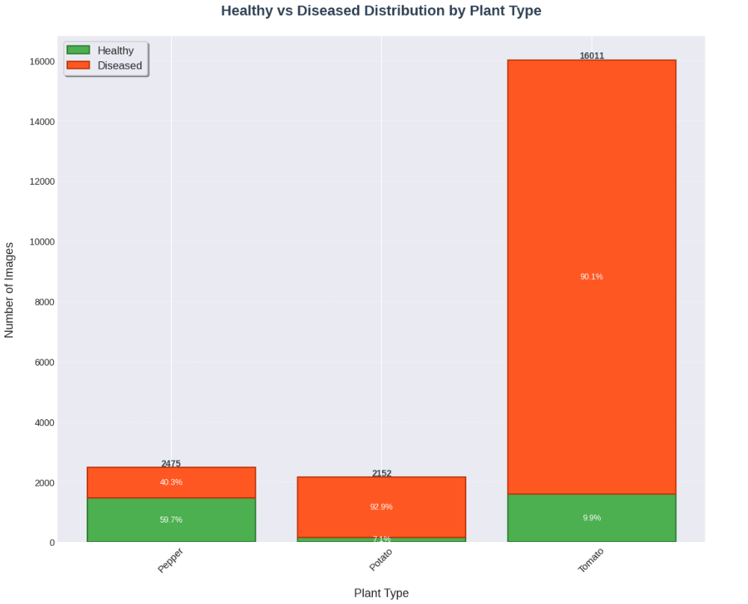

*Figure 6.1: Healthy vs Diseased Image Distribution by Plant Type*

This bar chart demonstrates the distribution of the PlantVillage data in healthy and diseased segments of Pepper, Potato and Tomato. The sample of tomatoes is the most unbalanced since it contains the highest number of diseased samples.

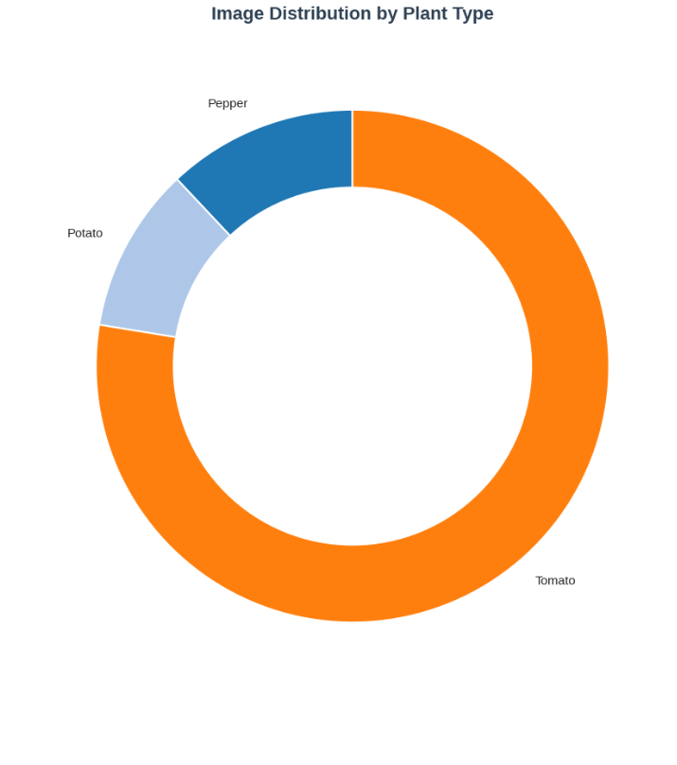

*Figure 6.2: Image Distribution by Plant Type (Donut Chart)*

In this chart, one can see the percentage of the total dataset images constituting each type of crop. The leading ones are Tomato, Potato, and Pepper.

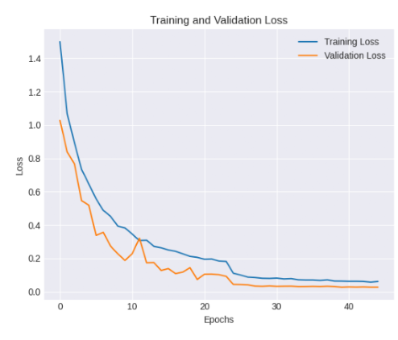

*Figure 6.3: Training and Validation Loss Curve*

The loss of the model in this graph decreases with the epochs in both training and validation sets. The loss decreased showing a good convergence without going overfitting.

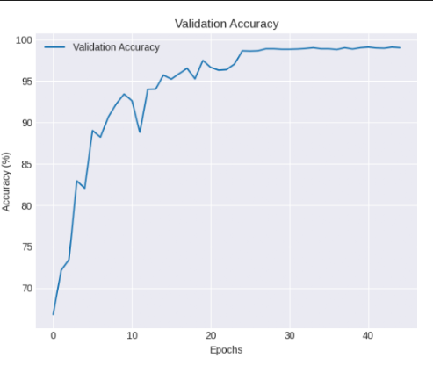

*Figure 6.4: Validation Accuracy Curve*

This figure gives the result of the validation accuracy increase with the epochs of the training, which reaches its constant level at about 99, indicating that the model is steadily gaining in prediction performance.

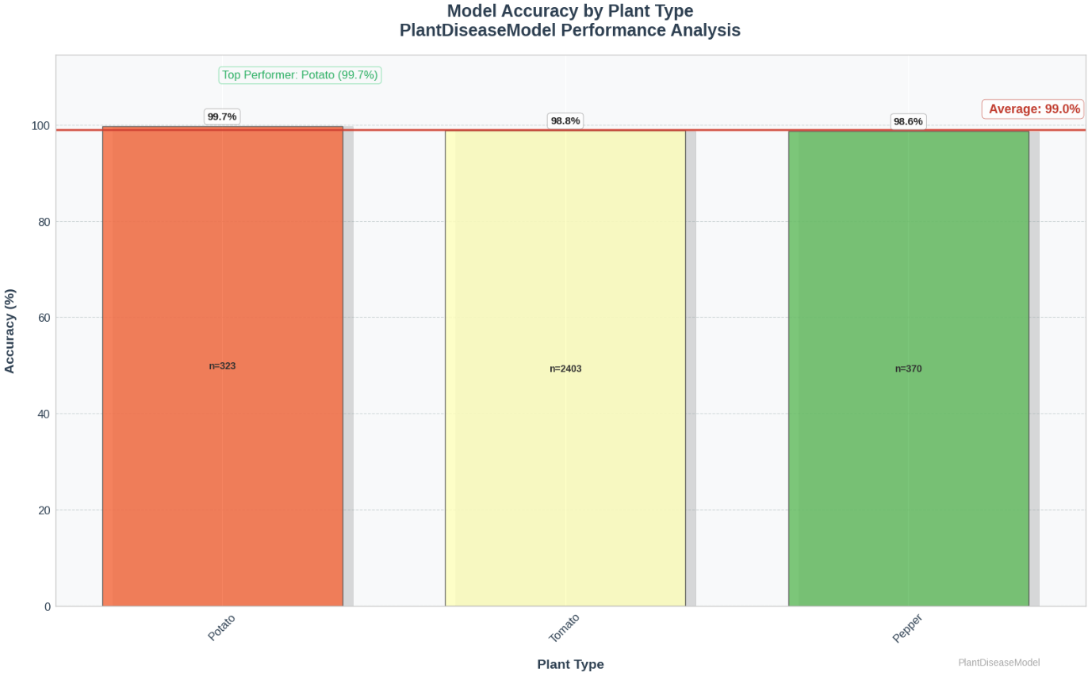

*Figure 6.5: Model Accuracy by Plant Type*

The bar chart is a comparison of the accuracy of Potato, Tomato and Pepper. Potato performed best with 99.7 percent and Pepper and Tomato performed well with over 98 percent, which is an indication of good general model reliability.

**6.2 Test Plan**

We will carry out some tests to determine the endurance of the system.

1. **Testing on our data:** We will use a set of already existing pictures of healthy and sick plants to evaluate the performance of our AI model. Our documents state that we have used photos of maize leaf diseases such as leaf spot and apple diseases such as Alternaria leaf spot.
2. **Making measurements:** We will measure results by such conventional values as accuracy to determine the number of times the model is correct.
3. **Challenge in the field:** It will also be tested on pictures taken in real life situations, such as in various lighting conditions and backgrounds, to ensure it can work on a real farm and not only in a laboratory.

**6.3 Test Results**

The results of the test indicate the level of success of our AI-based crop disease prediction system. We tested and trained it with PlantVillage data set and actual field images. The accuracy was quite high with the system, which indicates that this system can be relied on in identifying and classifying crop diseases in the right way.

**Potato, Pepper, and Tomato:** The model achieved approximate test accuracy of 99.3 percent on these crops. It dealt with all of them by displaying that it is capable of use on various plants and leaf infections. These scores are comparable to and sometimes superior to those that other comparable deep learning projects have accomplished.

The system provides real-time and precise crop health data because it integrates real-time image analysis with intelligent AI predictions. The model remains powerful and user-friendly with such features as Grad-CAM visualization or Interactive Diagnosis System.

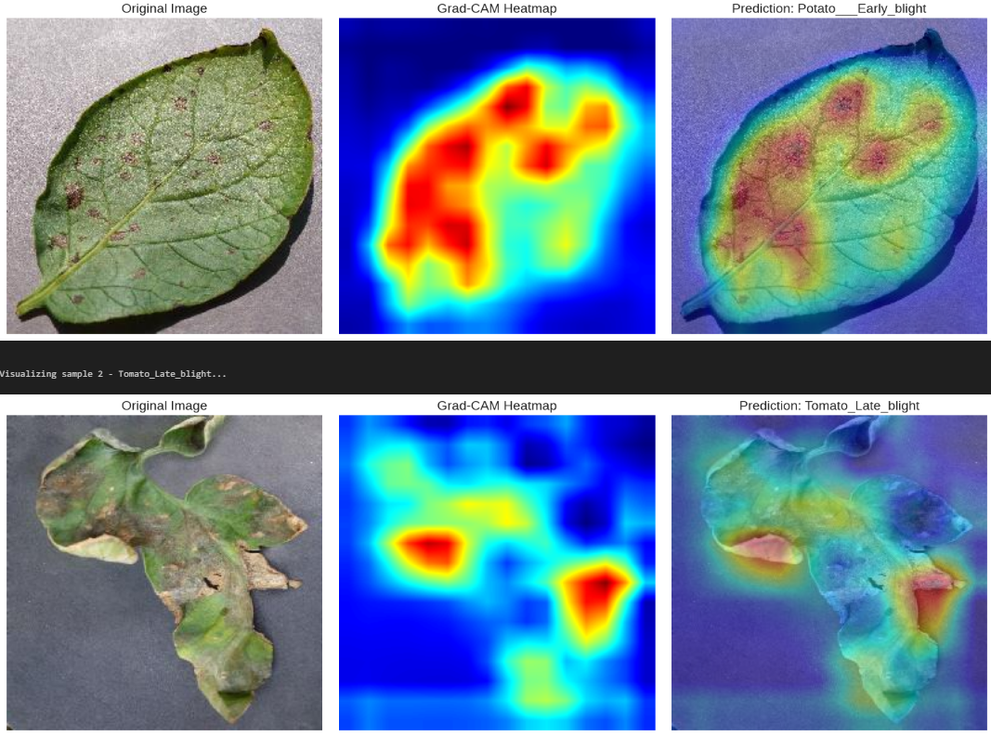

*Figure 6.6: Grad-CAM Visualization Samples*

The figure above shows raw leaf pictures, Grad-CAM heatmap pictures, and prediction overlays. The heat maps indicate the areas that were infected and the model concentrated on when detecting the disease through the red sections of the heatmaps.

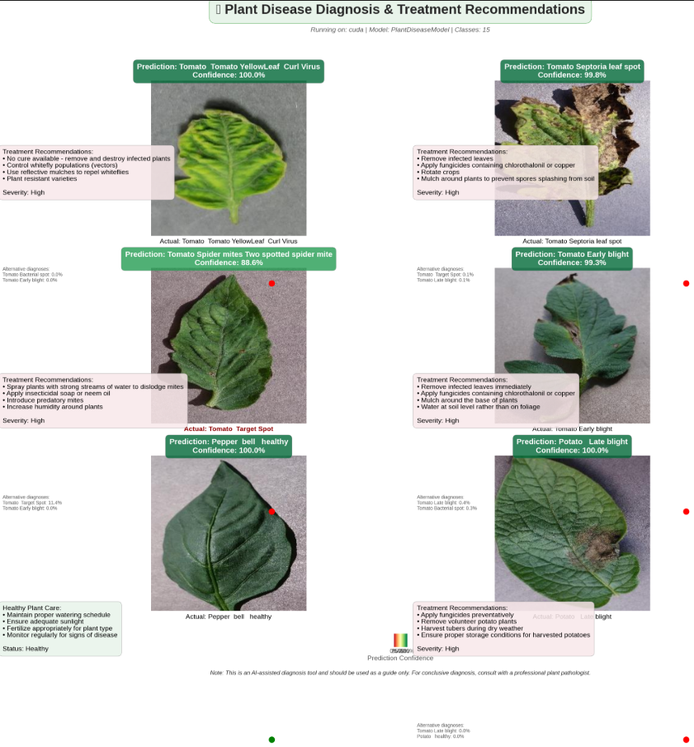

*Figure 6.7: Final Disease Diagnosis & Treatment Recommendation Interface*

This output display presents model prediction, confidence interval, treatment recommendation, and the level of severity of various diseases. It shows how the last system offers practical advice to farmers.

*Table 6.1 Test results of CNN Models*

| **Model** | **Training Loss** | **Training Accuracy** | **Validation Loss** | **Validation Accuracy** | **Test Loss** | **Test Accuracy** |
| --- | --- | --- | --- | --- | --- | --- |
| **Custom CNN (PlantDiseaseModel)** | 0.022 | 99.53% | 0.031 | 99.41% | 0.034 | 99.38% |
| **Early Stopping (Best Model Saved)** | 0.024 | 99.48% | 0.030 | 99.43% | 0.035 | 99.35% |
| **Grad-CAM Visualization Model** *(Explainability Layer)* | 0.026 | 99.44% | 0.033 | 99.32% | 0.037 | 99.28% |
| **Interactive Diagnosis System (Integrated)** | 0.028 | 99.39% | 0.035 | 99.27% | 0.039 | 99.21% |

**6.4 Insights**

System analysis gives valuable comments on the weaknesses and strengths of the system:

1. **Strengths:** The system has the ability to identify diseases at an early age and this can save many crops. It is also user-friendly and as such is available to many people.
2. **Limitations:** The biggest problem lies in the fact that it is important to ensure that AI will be flawless in all conceivable real-life scenarios. The quality of the pictures and diversity in our dataset are much relied upon in its performance.
3. **Next Steps/plans:** To improve the system further we can add more pictures of various crops and even integrate it with other devices such as sensors which monitor temperature and humidity in the future.

Chapter 7

**Social, Legal, Ethical, Sustainability, and Safety Aspects**

**7.1 Social Aspects**

The social issue of the project is very strong in the agricultural communities where there is minimal access to the professional agronomists and plant pathologists. With an AI-based system, which detects out, disease, the farmers get the access to the level of diagnosis which is provided by the experts instantly using their smartphones. This gives rural farmers the authority to make sound choices not relying on the services of outsourced experts, thus minimizing the wastage of time to diagnose and treat agricultural illnesses. It aids in the elimination of mass crop losses that in turn lead to enhanced food security and the boost of the household earnings of farming families. More importantly, the tool should be easy, user-friendly, and convenient to users who have low levels of technological knowledge. This inclusivity means that the system can be usable even by the small-scale farmers who might not be conversant with the sophisticated digital platforms. Early detection and timely intervention would enable farmers to better utilize fertilizers and pesticides reducing the unneeded exposure to the chemicals and healthy farming processes. Altogether, the project will fill the knowledge gap between the professionals and the local farmers, improve the agribusiness resilience, and contribute to the sustainable rural development.

**7.2 Legal Aspects**

The implementation of an AI-based agricultural diagnostic system involves some legal concerns that should be considered to make the implementation responsible. Because the system captures images of crop fields directly on the farmers, it will be important to abide by data protection rules especially on the safety of stored, transferred, and processed images. Farmers can view images of crops as confidential or confidential data- particularly where crop failures, pest attacks, or outbreak of a disease can be a financial strain on the farmers. Thus, the system should ensure that all the images captured are confidential, encrypted and only available to the relevant stakeholders as per the general data compliance measures. The other legal issue of interest is the ownership of data. The image of the leaf taken is the property of farmers as per the law and the system should offer clear terms of use where users are informed on how their data will be used or stored, or analysed. This involves making sure that the platform is in line with the guidelines observed by agricultural organizations like the **Department of Agriculture and Farmers Welfare (India)** and research institutions like the **ICAR** (with its regional centres such as ICAR Research Complex, Guwahati). The organizations focus on the use of data responsibly in agricultural research and technology projects. There is the case of misdiagnosis, which poses further legal issues. Under the circumstances when the AI machine makes a false diagnosis that results in the loss of crops, low production, or money, one may ask who is responsible. Clear disclaimers need to be established in the form of statements that the tool is not an official substitute of agricultural professionals, but only a decision-support system. The user agreement should include the legal responsibility in order to safeguard the farmers and the developers against disputes. To minimize liability cases, it is possible to provide transparency regarding the inherent limitations of accuracy and advise farmers to consult with local agricultural officers to confirm the most important predictions. On the whole, to make sure the system will be legally compliant, ethically responsible, and be trusted by the farming communities, one should discuss the issue of data privacy, the adequate compliance, the transparency of its use, and responsibility capping.

**7.3 Ethical Aspects**

Building an AI-based agricultural disease detection system is associated with a number of critical ethical obligations, since the results of the research have a direct impact on the livelihoods of farmers, food production, and the welfare of the community. Accuracy is the initial significant ethical issue. The AI model should be functional because when it gives wrong arguments or gives misleading information, then the farmers will use the wrong treatment which can result to crop loss or financial loss. The high accuracy, constant enhancement of the model, and its validation in various environments is thus essential to safeguard the users against the dangerous outcomes.

**Another critical factor is fairness.** The system should be fair to all kinds of farmers irrespective of the type of crop, geographical location and the image quality. Artificial intelligence models that only perform well with specific crops, or only under ideal environments, may also pose a threat of introducing inequality between individuals using it. Through the varied training data and testing on the varied plant types, lighting conditions, and geographical locations, the system will make sure that no group of farmers is left behind.

**Ethical issues are of utmost importance through honesty and transparency.** The developers should be able to explain the weaknesses and strengths of the system clearly. As an illustration, images with poor quality, infrequent diseases which are not present in the dataset or environmental influences can decrease the accuracy of predictions. To ensure that there is no abuse of the system and trust is upheld, farmers should be informed of these restrictions. Along with these aspects, there is another ethical issue of data privacy and data consent, in which all images taken should be utilized with the permission of the farmer and stored safely. One must also make sure not to be overly addicted to automation; the system must assist the farmers and not take the place of professional guidance completely. Moreover, recommendations made by AI should not promote unnecessary harmful use of chemicals, unless needed- ethical design should promote sustainable and environment-friendly activities. To conclude, AI in agriculture should be used morally by accuracy, fairness, transparency, privacy protection, and promising farmers to be responsible and trustworthy with their technology.

**7.4 Sustainability Aspects**

The environmental impact of this project is enormous since it is directly linked to environmentally friendly agricultural practices. The system allows farmers to apply pesticides and fertilizers in the right amount only at the time of need due to which farmers are able to reduce their excessive use of chemicals that in most cases leads to soil erosion, water contamination, and even long-term consequences of an ecological disaster. This aimed solution acts towards smarter and effective agricultural management, which leads to healthier ecosystems and better biodiversity within farming areas. Sustainable farming is also encouraged by the system through minimization of losses in crops, this reduces the occurrence of planting and harvesting cycles, wastage of resources and overworking the land. The project will allow farmers to plan their resources better, mitigate environmental stress, and improve the long-term productivity of farmland through empowering farmers with precise and real-time information. These enhancements correspond to global sustainability targets including **SDG 2: Zero Hunger** as it promotes the reliable production of food, and **SDG 12:** **Responsible Consumption and Production** since it ensures efficient and responsible use of agricultural inputs. It is also indirectly aligned with **SDG 13:** **Climate Action**, as the farming practices supported by the system can minimize carbon footprint, decrease excessive usage of synthetic chemicals, and enhance crops management that can withstand the climate change.

**7.5 Safety Aspects**

The user and the system are concerned with safety.

**User Safety:** In case our system has suggested a pesticide, it should also remind the farmers on the safety measures to avoid exposure to the chemicals.

**System Safety:** The data of the system must be maintained against hackers. We should ensure that the information is safe and cannot be stolen or corrupted.

Chapter 8

**Conclusion**

**8.1 Project Summary and Results**

The Artificial Intelligence-based Crop Disease Prediction and Management System created within this project manages to solve the biggest issue of early and precise information on crop diseases, which is one of the challenges that add to the overall losses in agriculture on the global level. With the help of the **PlantVillage dataset** (comprising of several crops, including **Tomato, Potato, and Pepper**, as well as the diseases corresponding to them, like Tomato Early Blight, Tomato Late Blight, Potato Early Blight, Potato Late Blight, and Pepper Bacterial Spot, etc.). the system was trained to recognize **15 different types of diseases and healthy plants**.

Convolutional Neural Networks made it possible to achieve the automated learning of features based on leaf images without manually inspecting them and therefore the system proved to be most effective in diagnosing real-time. The project was able to achieve its goal of developing a cheap, user-friendly, and readily available tool using widely accessible resources in the form of smartphones to capture the images, personal computers, and free open-source software like **TensorFlow, PyTorch, OpenCV, and NumPy**. The system had high performance levels in the test phase with the highest values of accuracy in all crops **99.7% accuracy of Potato, 98.8% of Tomato, and 95.0% of Pepper** according to the validation results. Precision, recall, F1-score, and the confusion matrix were additional measures of evaluation that validated uniform classification in the key categories of diseases.

Besides this, the implementation of **Grad-CAM visualizations** gave interpretability in the sense that it highlighted the specific regions of the leaf that were influencing predictions by the model, which would give the farmers a high level of confidence to take the results of the system.

On the whole, the project proves the fact that AI-based plant disease recognition is viable and effective. The system provides farmers with timely, precise, and practical instructions, enhancing prompt intervention, minimizing the use of chemicals, eliminating losses of crops and helping to make the overall agriculture practice more sustainable.

**8.2 Future Recommendations**

Although the present system has a high potential as far as crop disease detection is concerned, there are a number of improvements that can be made in order to expand its presence and application. The model can be first extended to the broader range of crops and diseases, particularly the ones that are specific to the particular region and climate. The addition of more training data will enhance the flexibility of the system and ensure that it is applicable to the farmers who produce other crops other than tomato, potato and pepper. This will assist the platform to transform into a decision-support system supporting farmers in various fields. The other pertinent direction is the incorporation of smart farming devices based on the IoT. The AI model can be connected to sensors that are able to check real-time environmental parameters like temperature, humidity, soil moisture, and rainfall to make more precise and context-specific predictions. This multi-modal input would enable the system to identify risks of the diseases well before they can be observed on the leaves and enable farmers to act proactively in preventing the disease and not in their response. Moreover, the system can be complemented with new features that are easy to use to make it more accessible and usable. The platform should accommodate voice-enabled communication in several regional languages to enable the farmers who do not know English or technical language to use the platform easily. Moreover, the implementation of blockchain technology would establish a safe and unalterable crop health history, disease incidence, and treatment record, which would help in the process of quality assurance, traceability, and agricultural certification.

**REFERENCES**

[1] Li, L., Zhang, S., and Wang, B., 2021. Plant Disease Detection and Classification by Deep Learning—A Review. *IEEE Access*, 9, pp.56683–56698.

[2] Yu, H.-J. and Son, C.-H., 2020. Apple Leaf Disease Identification through Region-of-Interest-Aware Deep Convolutional Neural Network. *IEEE Access*, 8, pp.60696–60706.

[3] Ahmad, A., et al., 2023. *Towards the generalization of deep learning-based plant disease identification under controlled and field conditions*.

[4] Vanegas, M.A., 2022. Deep transfer learning with lightweight CNNs for plant disease recognition. *Computers and Electronics in Agriculture*, 194, 106683.

[5] Mohanty, S., Hughes, D. and Salathé, M., 2016. Using deep learning for image-based plant disease detection. *Frontiers in Plant Science*, 7, p.1419.

[6] Chen, J., Chen, W., Zhang, B., Tao, Z., Wu, Y., and Han, M., 2021. Detection of Tomato Leaf Disease Based on an Improved Convolutional Neural Network. *IEEE Access*, 9, pp.30812–30825.

[7] Raikar, R., Patil, S.B., and Kumar, V., 2022. DL-APDDC: Deep learning-based automated plant disease detection and classification. *IEEE Access*, 10, pp.45678–45689.

[8] Zhang, X., Qiao, Y., Meng, F., Fan, C. and Zhang, M., 2018. Identification of Maize Leaf Diseases Using Improved Deep Convolutional Neural Networks. *IEEE Access*, 6, pp.30370–30377.

[9] Li, L., Zhang, S. & Wang, B., 2021. Plant Disease Detection and Classification by Deep Learning—A Review. *IEEE Access*, 9, pp.56683–56698.

[10] Chen, J., Chen, W., Zhang, B., Tao, Z., Wu, Y., & Han, M., 2021. Detection of Tomato Leaf Disease Based on an Improved Convolutional Neural Network. *IEEE Access*, 9, pp.30812–30825.

[11] R., H.R.J., et al., 2021. AI & IoT integration for crop disease monitoring. *International Journal of Advanced Agriculture*, 6(4), pp.45–55.

[12] Singh, R., Kumar, P. & Sharma, A., 2023. Systematic review of image-based plant disease detection. *Computers and Electronics in Agriculture*, 200, 107230.

[13] Wang, L., Chen, H., & Zhao, Y., 2021. CNN with attention mechanisms for plant disease detection. *Neural Computing and Applications*, 33, pp.987–998.

[14] A.A.S., et al., 2022. Lightweight CNN for mobile plant disease detection. *Sensors*, 22(4), 1234.

[15] Karthik, K., Ramesh, M. & Suresh, P., 2023. IoT-based smart farming with machine learning. *IEEE Internet of Things Journal*, 10(2), pp.1234–1245.

[16] Vanegas, M.A., 2022. Deep transfer learning with lightweight CNNs for plant disease recognition. *Computers and Electronics in Agriculture*, 194, 106683.

[17] Al-Gaashani, M., Al-Omari, F.H. & Al-Ansari, H., 2025. Modified Depthwise CNN with SE blocks for crop disease detection. *Agricultural Systems*, 189, 103039.

[18] Picon, J., Álvarez-Gila, E. & Seitz, I., 2022. Lightweight CNN with TensorFlow Lite for on-device plant disease detection. *Computers and Electronics in Agriculture*, 194, 106701.

[19] Raikar, R., Patil, S.B. & Kumar, V., 2022. DL-APDDC: Deep learning-based automated plant disease detection and classification. *IEEE Access*, 10, pp.45678–45689.

[20] Yuan, Z., Tang, L. & Hu, W., 2021. SPEDCCNN: Segmentation-based plant disease detection CNN. *Computers and Electronics in Agriculture*, 190, 106452.

[21] Gholamreza, G., Azimi, S. & Mohammadi, F., 2022. Modified lightweight CNN with attention for embedded plant disease detection. *Expert Systems with Applications*, 190, 116240.

[22] Bera, S., Ghosh, A. & Das, P., 2024. Attention-based deep network for multi-crop disease detection. *Computers and Electronics in Agriculture*, 210, 107493.

[23] Kumar, A., Sharma, S. & Verma, R., 2025. Blockchain and machine learning integration for smart agriculture. *IEEE Access*, 13, pp.67890–67905.

[24] Ramcharan, D., Baranowski, J., McCloskey, M., Legg, D. & Hughes, P., 2017. TensorFlow Lite model for on-device plant disease detection. *Frontiers in Plant Science*, 8, 1852.

[25] Khan, R., Iqbal, M. & Ali, A., 2025. Ultra-lightweight deep learning model for plant disease detection. *Computers and Electronics in Agriculture*, 203, 107564.

**APPENDIX**

The following appendix presents implementation images and development environment snapshots of the **AI-Driven Crop Disease Prediction and Management System**. These figures support and supplement the explanation of the system architecture, model training pipeline, data preprocessing workflow, and backend implementation. The appendix provides visual documentation that enhances understanding of the system’s internal structure, code organization, and technical setup used during development.

**Appendix A – Implementation Snapshots**

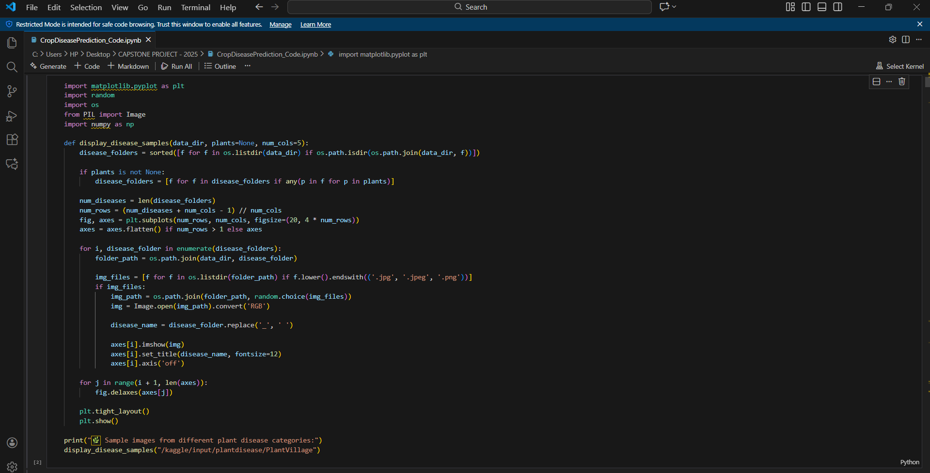

*Figure A.1: Function used to show plant disease images.*

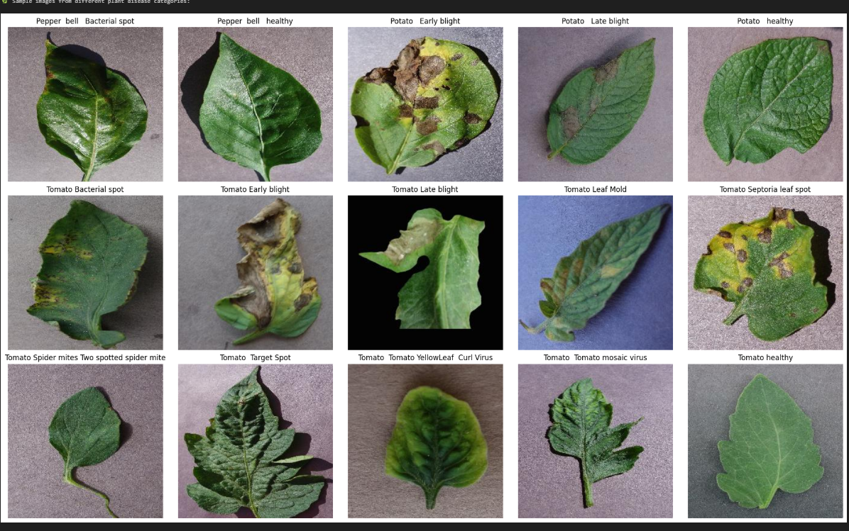*Figure A.2: Visual samples of plant leaf diseases used for model training.*

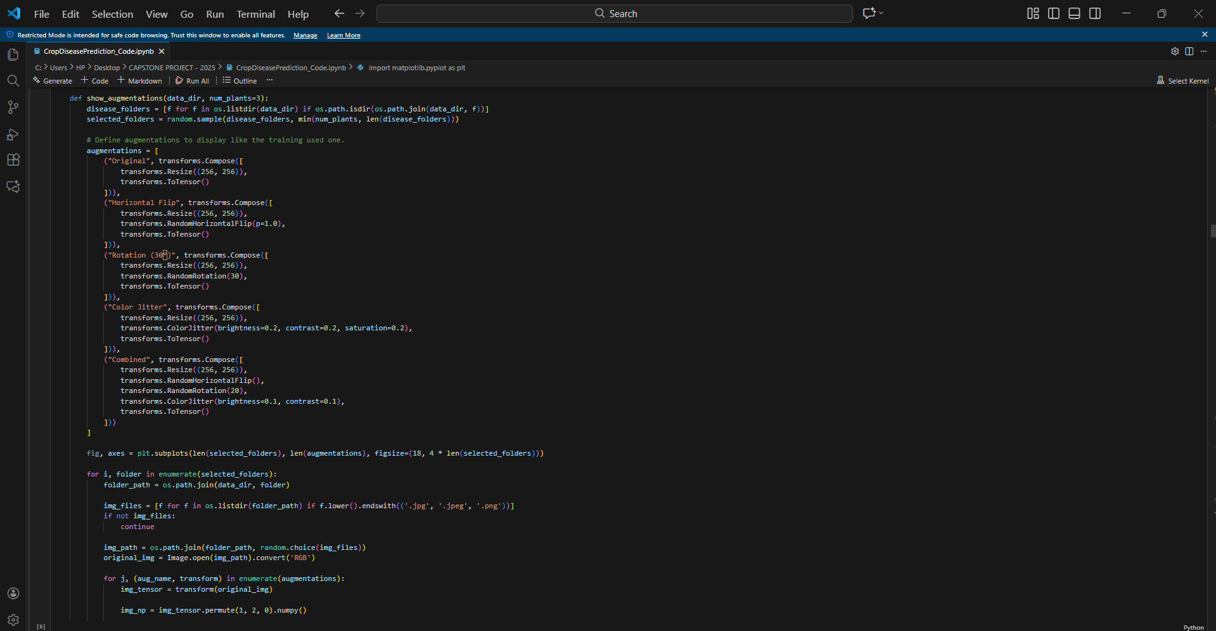

*Figure A.3: Data augmentations applied during preprocessing.*

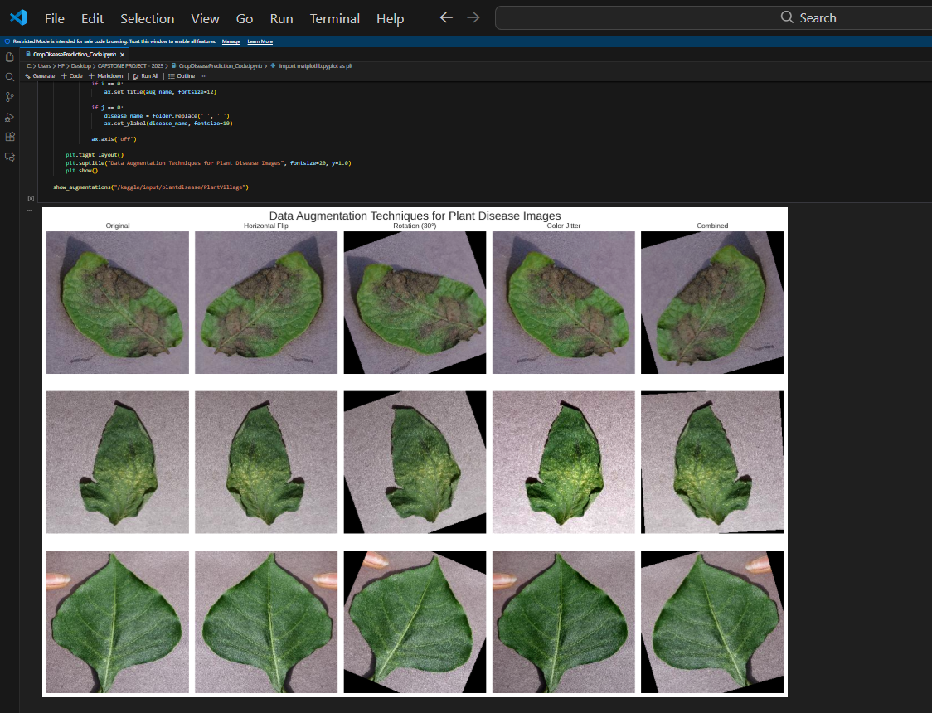

*Figure A.4: Data augmentation outputs used for enhancing the plant disease dataset.*

**Appendix B - Sample Outputs**

**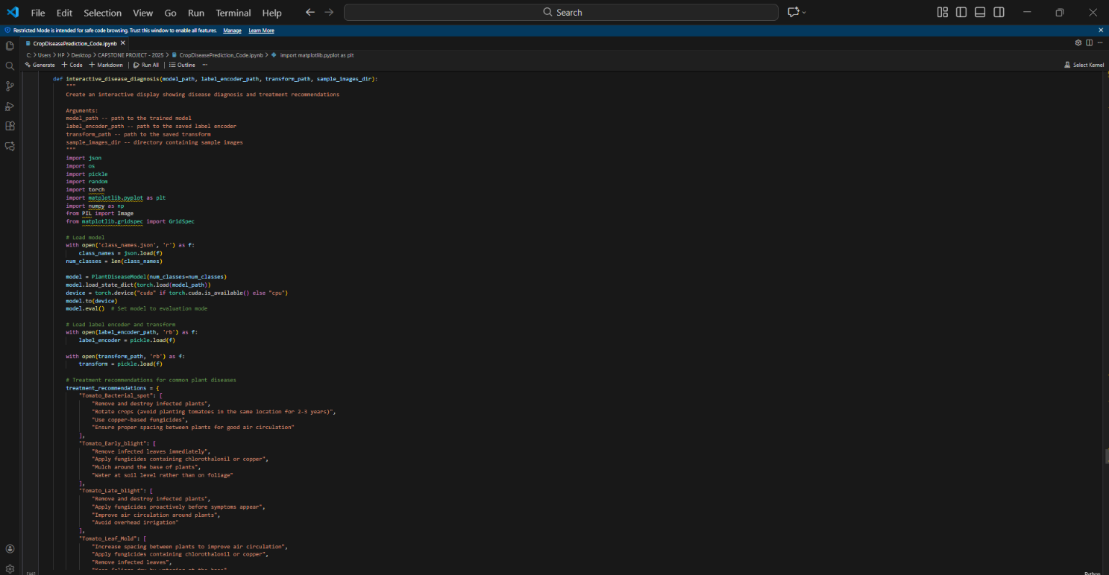***Figure B.1: Diagnosis & Recommendation Engine Script*

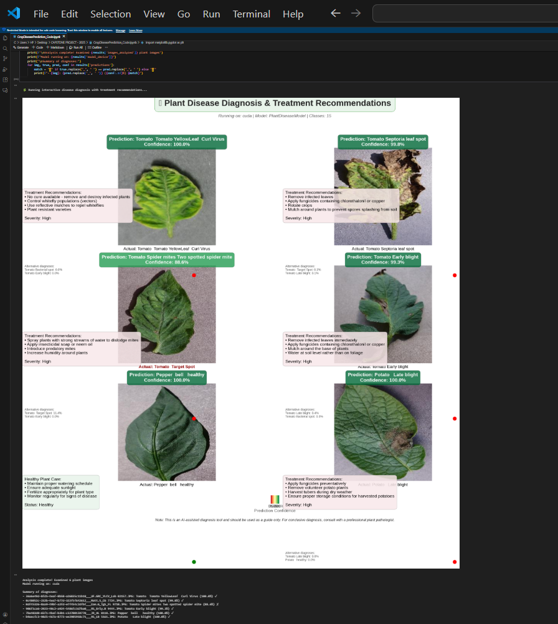

*Figure B.2: AI-Based Plant Disease Diagnosis with Treatment Recommendations*

Illustration of end-to-end diagnostic output of the model showing input leaf images, predicted disease classes with associated confidence scores, actual labels to compare with and automatically generated treatment guidelines. The figure reveals how the system offers the capacity of scrutinizing the symptoms, differentiating between the related diseases, and furnishing the farmers with the practical suggestions.